Report from the Tom Farrell Institute for the Environment’s Mine Rehab Conference 2017

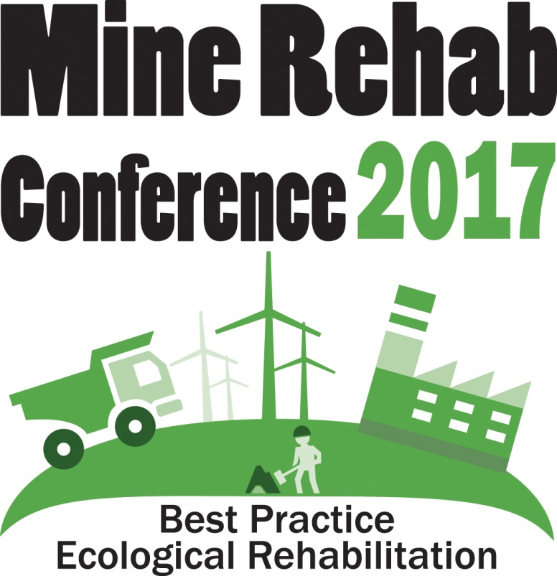

Executive Summary

The 7th Annual Best Practice Ecological Rehabilitation of Mined Lands Conference (2017) was held on 29, 30 & 31 March 2017 at Muswellbrook, NSW, organised by the Tom Farrell Institute for the Environment (TFI). The conference had 218 delegates (sell out!), and had 17 speakers, 11 poster presentations, 8 sponsors, 10 exhibitors, and a panel discussion. In addition to the main conference there were 3 workshops, 2 mine tours, a civic reception, and a cocktail dinner.
Similar to the broad variety of attendees, speakers included rehab professionals, industry, government, and education.
Results of an attendee survey indicated a very satisfaction with the conference, with approximately 80% of respondents noting the conference met or exceeded their expectations and over 89% saying they would re-attend.

Conference background

The 7th Annual Best Practice Ecological Rehabilitation of Mined Lands Conference (2017) [See http://www.tomfarrellinstitute.org/2017-mine-rehab-conference.html ] was held on 29, 30 & 31 March 2017 at Muswellbrook, NSW, organised by the Tom Farrell Institute for the Environment (TFI). The TFI is a multidisciplinary organisation which is well placed as the University of Newcastle’s Environmental outreach arm, to engage with Australia’s leading professionals involved in the broader environmental fields.
This annual conference is a significant event on the Hunter Region calendar. It provides an important avenue for TFI to promote the use of best-practice approaches in the management of rehabilitation of mined lands.
The main conference sold out this year, with 218 attendees (See Figure 1 below), making it one of the largest mining rehabilitation conferences in Australia. The breakdown of attendance figures was approximately 45% Rehab Professionals, 20% Industry, 18% Government, and 16% Education, and 1% Community. (See Figure 2 Delegates by their field of work, below)
Due to the large number of excellent abstracts received, the conference was expanded to include an additional day this year. This year our event was held over 3 days. Across these three days, delegates had the opportunity to participate in various activities, including workshops, mine tours as well as the main conference.
The 2017 Conference attracted:
- those with a professional interest in Mined Land Rehabilitation
- regulatory officers involved in the mining sector, Policy development and implementation
- new researchers, recent PhD, Masters and Honours graduates
- individuals and organisations representing the mining community and associated supply chains
- researchers and research institutes; and broader community
A broad variety of speakers presented at the conference, with approximately 24% Rehab Professionals, 18% Industry, 24% Government, and 34% Education.
​The purpose of the Mine Rehab Conference was to bring Mine Rehabilitation Stakeholders together to share our current best practices, and to discuss what we do well & what we can improve & what we would like the future to be.
In addition to the main conference, the following events were held:
MINE TOURS (Wed. afternoon)
- Muswellbrook Coal thence BHPB- Mount Arthur
- Mount Thorley Warkworth thence Rix’s Creek
WORKSHOPS
- Landform evolution modelling for mine rehabilitation EAMS-SIBERIA (Wed 3-5pm),
- Pathways to relinquishment and opportunities to transition to productive alternate land uses (Fri 11am-2:30pm), and
- New practices to advance mine rehab in the Hunter Valley ( Fri 11am-2:30pm)

SOCIAL EVENTS
- Civic welcome (Wed. evening) The Upper Hunter Conservatorium of Music. Bridge Street, Muswellbrook
- Networking Dinner (Thurs. evening) Muswellbrook RSL Bridge Street, Muswellbrook

http://www.tomfarrellinstitute.org/2017-mine-rehab-conference.html

Table 1 Front covers of the Conference's Brochure/Handbooks over the years
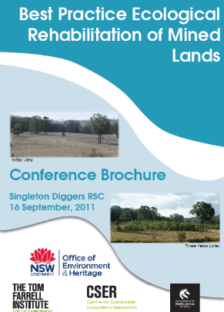 | 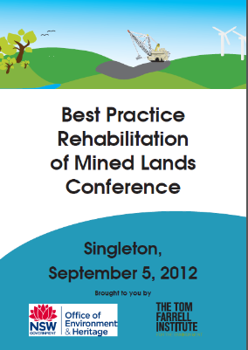 | 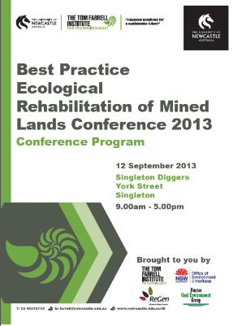 | 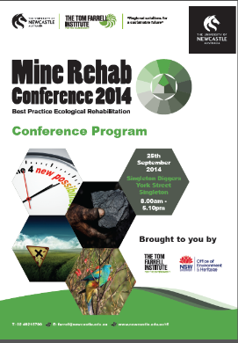
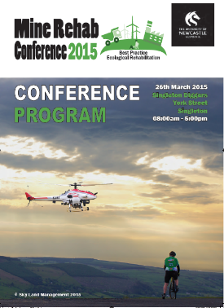 | 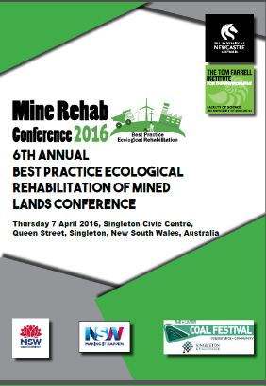 | 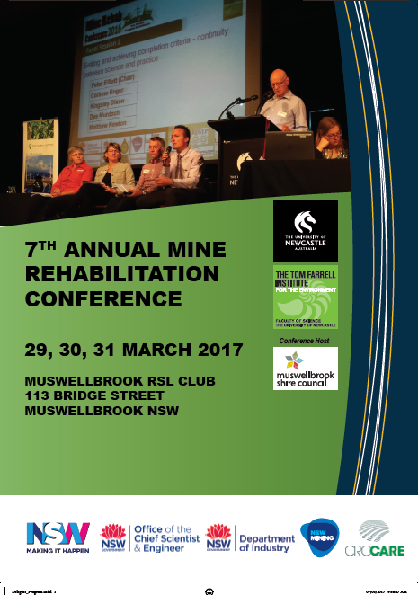

Table 2

Photographic report

Wed 29th March 2017:
- Mine tours in the afternoon.
- Civic reception in the evening

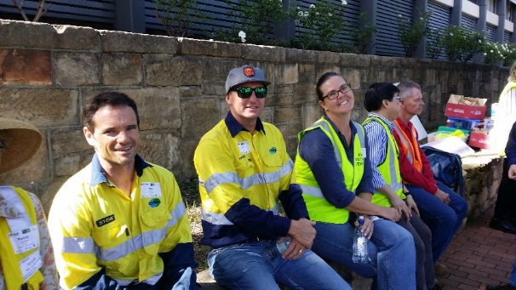  People awaiting mine tours outside Muswellbrook RSL 29.3.17 | 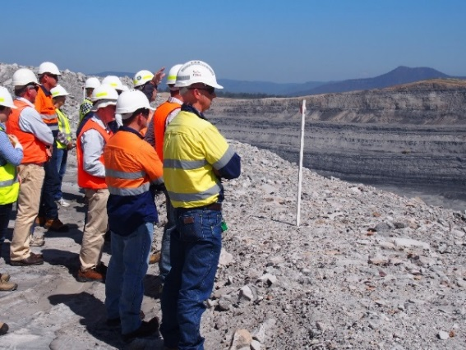  Tour onsite Mt Thorley Warkworth
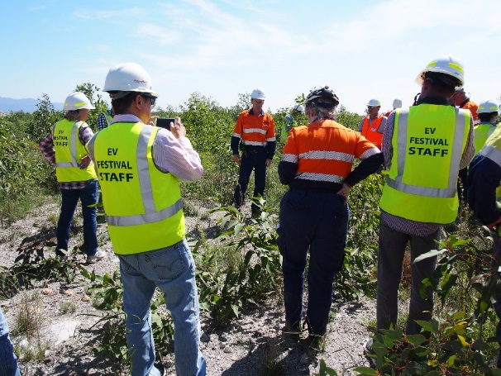  Inspecting revegetation at Mt Thorley Warkworth | 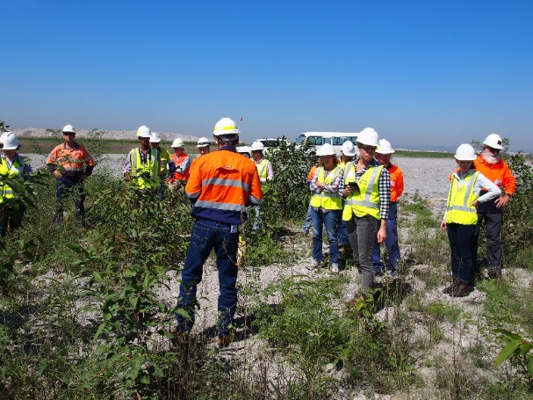  MTW with tour bus and escort vehicle
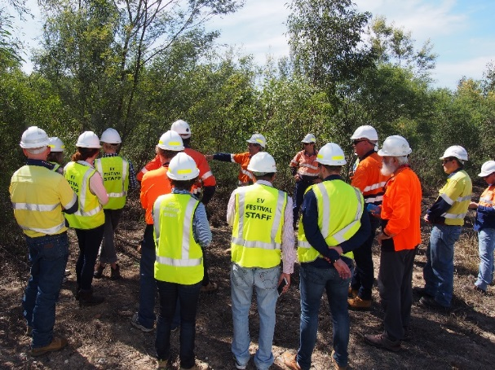 Taller revegetation at MTW | 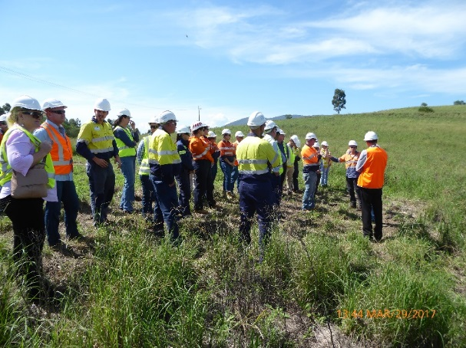  Inspecting the big artificial bowl at Muswellbrook Coal, a landscape feature deliberately created by the land forming process.
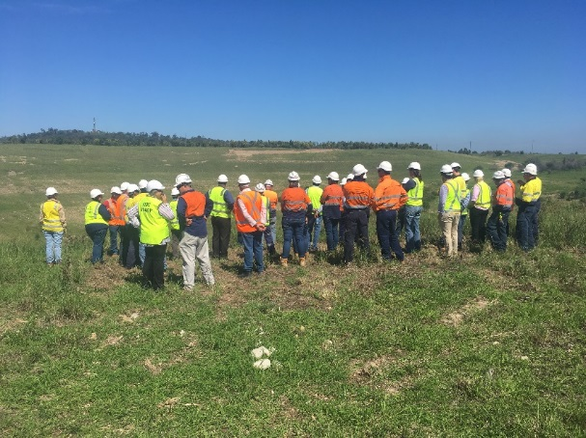  Inspecting the big artificial bowl at Muswellbrook Coal | 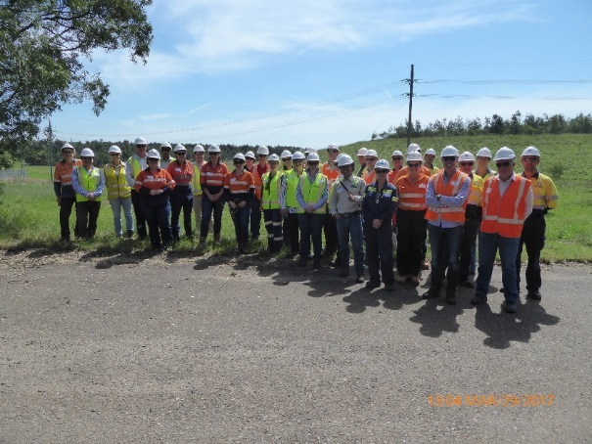  Family portrait in front of rehab Muswellbrook coal

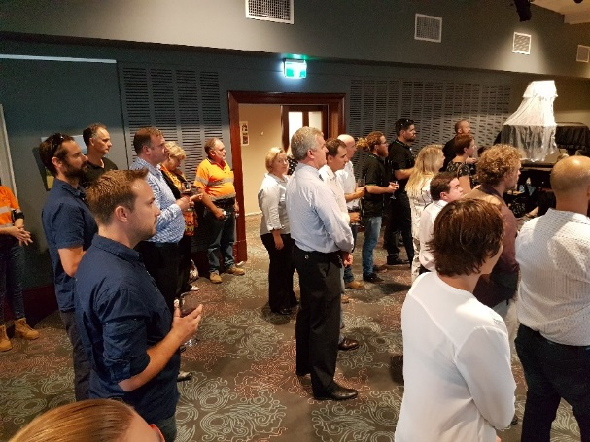  Soiree  Civic welcome Wednesday 29.3.17 | 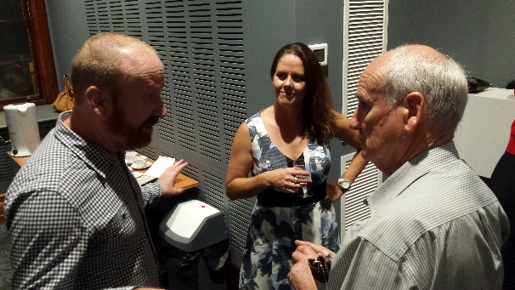  Tom Farrell Institute Tim Roberts (right) and Belinda McNab (centre) network with Muswellbrook Mayor Martin Rush (left)
Thu 30th: Full day of presentations with posters and panel session, followed by a dinner.
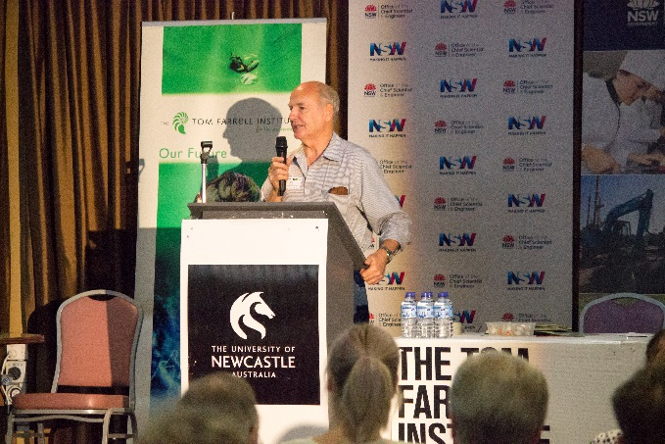 Professor Tim Roberts opening the Conference Thursday 30.3.17 | Thursday 30.3.17 conference delegates attend to Shannon Mulholland 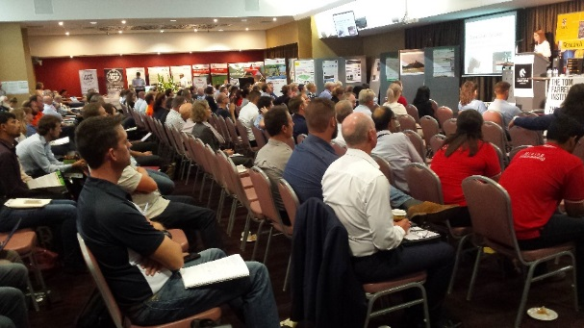
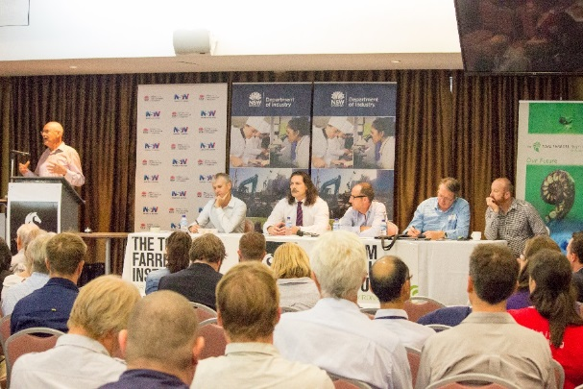 | Panel Session:  “Pathways to relinquishment and Opportunities to transition to productive alternate land uses”  L to R  Chair Peter Elliott  Richard Bush, David Blackmore, Stephen Barry, Andrew Keith, Martin Rush
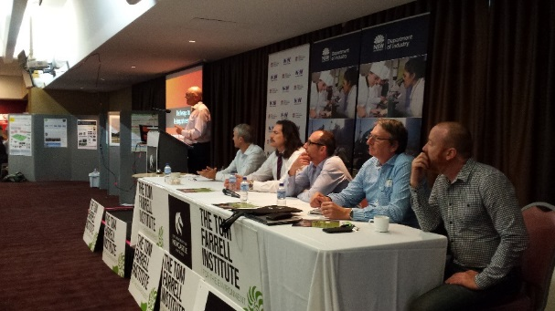 | 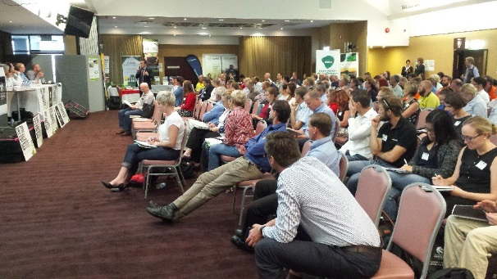
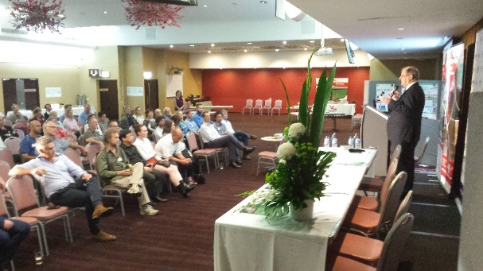  Alan Broadfoot addresses the Dinner Audience | 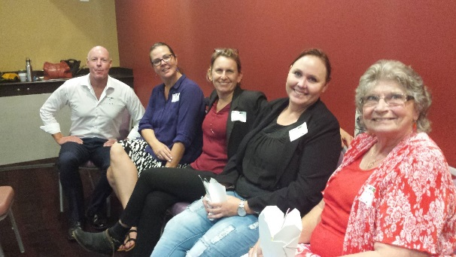  Some dinner participants chatting

Fri 31st: Presentations till 11am then there were two (2) concurrent workshops that ran until 3pm. The workshops included: New practices to advance mine rehab in the Hunter Valley, and Pathways to relinquishment and Opportunities to transition to productive alternate land uses.
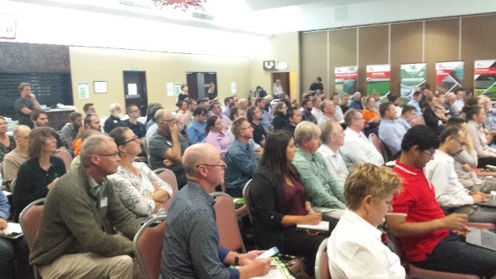  Crowd on Friday 31.3.17 | 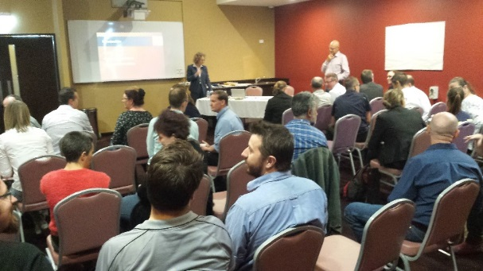  Workshop 31.3.17  “Pathways to relinquishment and Opportunities to transition to productive alternate land uses”
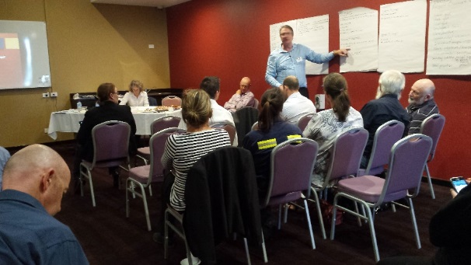 | Participant feedback to group  Workshop: “Pathways to relinquishment and Opportunities to transition to productive alternate land uses”  Report embedded here:  <<DOUBLE Click << box to open embedded Relinquishment workshop report

Registration

218 registrations were accepted. This is below 2016 (at 245 attendees).
Figure 1 Past conference delegate registrations 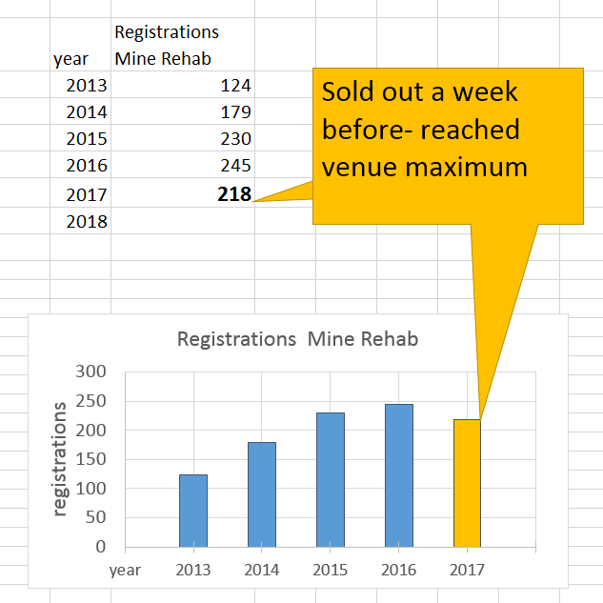

However, we were completely constrained by the venue configuration and we ceased accepting new registrants just over a week before the conference. {~ Monday 20th March 2017}. With the selling rate at about 30 to 40 seat per week we could perhaps extrapolate 218 +~ 30 =~ 250 +

Figure 2 Delegates by their field of work
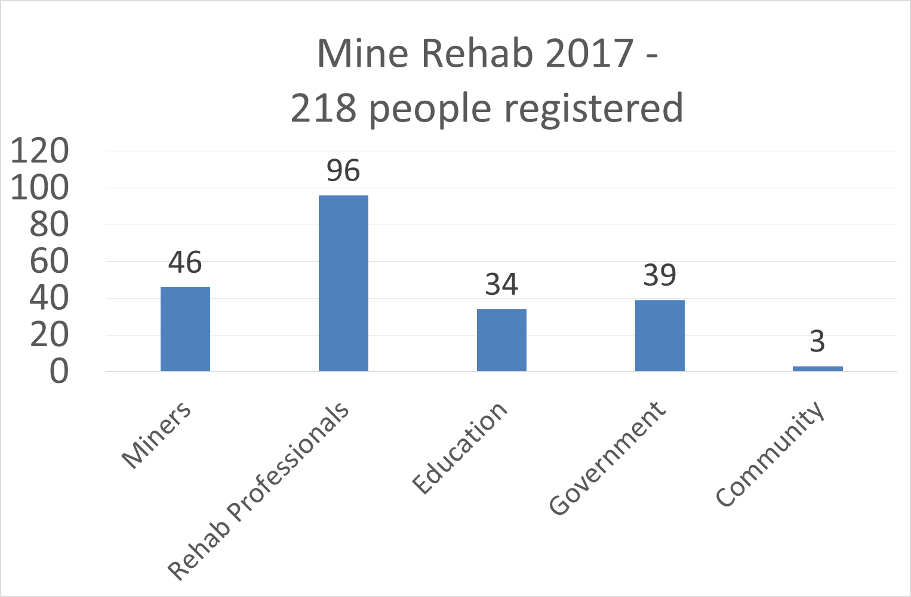

Survey

Satisfaction ratings for the overall conference rated very high, with approximately 80 percent of respondents being satisfied with the event which they noted met or exceeded their expectations for attending, and over 89 percent indicating they would attend again and recommend the conference to others. See Figure 3 Summary of Survey results MR 2017 below.
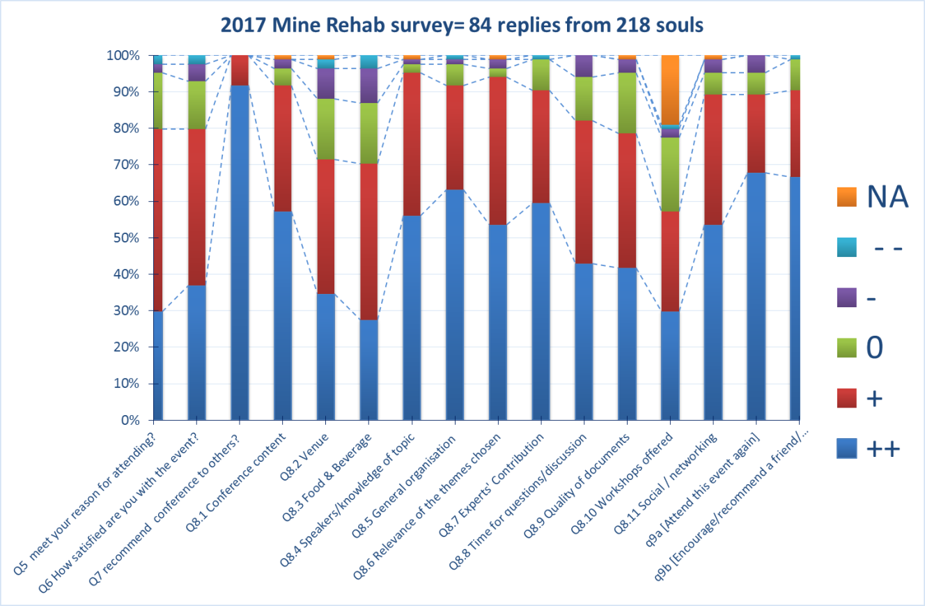
Figure 3 Summary of Survey results MR 2017

